Asset Log

Asset Name | Purpose of the Asset | Link | Date Retrieved
homecarrots | Home website image (AI-generated in Gemini) | home/homecarrots.jpg | 23/04/2026
homestrawberries | Home website image (AI-generated in Gemini) | home/homestrawberries.jpg | 23/04/2026
homeveg | Home website image (AI-generated in Gemini) | home/homeveg.jpg | 23/04/2026
manwalking | Home website image (AI-generated in Gemini) | home/manwalking.jpg | 23/04/2026
olderLady | Home website image (AI-generated in Gemini) | home/olderLady.jpg | 23/04/2026
produceBox | Home website image (AI-generated in Gemini) | home/produceBox.jpg | 23/04/2026
greenValleyProduce | Producers website image (AI-generated in Gemini) | producers/greenValleyProduce.jpg | 23/04/2026
meadowFreshOrganicFarm | Producers website image (AI-generated in Gemini) | producers/meadowFreshOrganicFarm.jpg | 23/04/2026
oakridgeHarvestHub | Producers website image (AI-generated in Gemini) | producers/oakridgeHarvestHub.jpg | 23/04/2026
sunnybrookFarm | Producers website image (AI-generated in Gemini) | producers/sunnybrookFarm.jpg | 23/04/2026
willowcreekFarm | Producers website image (AI-generated in Gemini) | producers/willowcreekFarm.jpg | 23/04/2026
apple | Products website image (AI-generated in Gemini) | products/apple.jpg | 23/04/2026
broccoli | Products website image (AI-generated in Gemini) | products/broccoli.jpg | 23/04/2026
carrot | Products website image (AI-generated in Gemini) | products/carrot.jpg | 23/04/2026
cauliflower | Products website image (AI-generated in Gemini) | products/cauliflower.jpg | 23/04/2026
cheese | Products website image (AI-generated in Gemini) | products/cheese.jpg | 23/04/2026
chickenbreast | Products website image (AI-generated in Gemini) | products/chickenbreast.jpg | 23/04/2026
egg | Products website image (AI-generated in Gemini) | products/egg.jpg | 23/04/2026
milk | Products website image (AI-generated in Gemini) | products/milk.jpg | 23/04/2026
mincemeat | Products website image (AI-generated in Gemini) | products/mincemeat.jpg | 23/04/2026
pear | Products website image (AI-generated in Gemini) | products/pear.jpg | 23/04/2026
potatoes | Products website image (AI-generated in Gemini) | products/potatoes.jpg | 23/04/2026
raspberry | Products website image (AI-generated in Gemini) | products/raspberry.jpg | 23/04/2026
strawberry | Products website image (AI-generated in Gemini) | products/strawberry.jpg | 23/04/2026
yogurt | Products website image (AI-generated in Gemini) | products/yogurt.jpg | 23/04/2026

Image Assets
All images below are AI-generated images from Gemini.
home/homecarrots.jpg
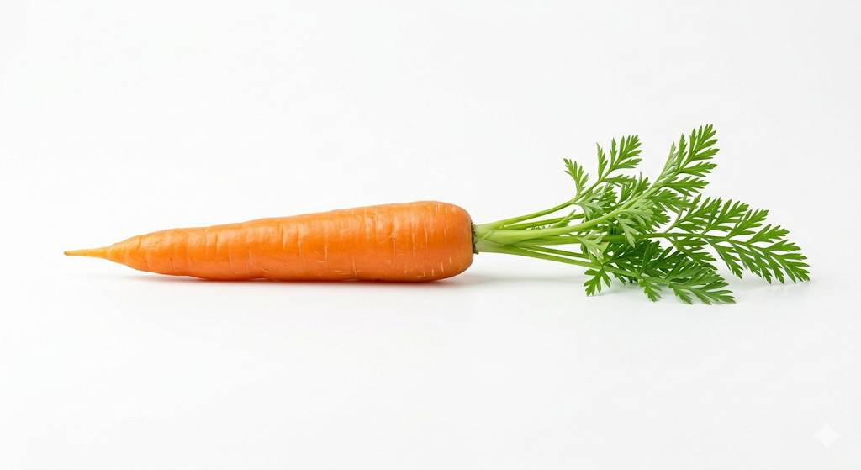
AI-generated image from Gemini
home/homestrawberries.jpg
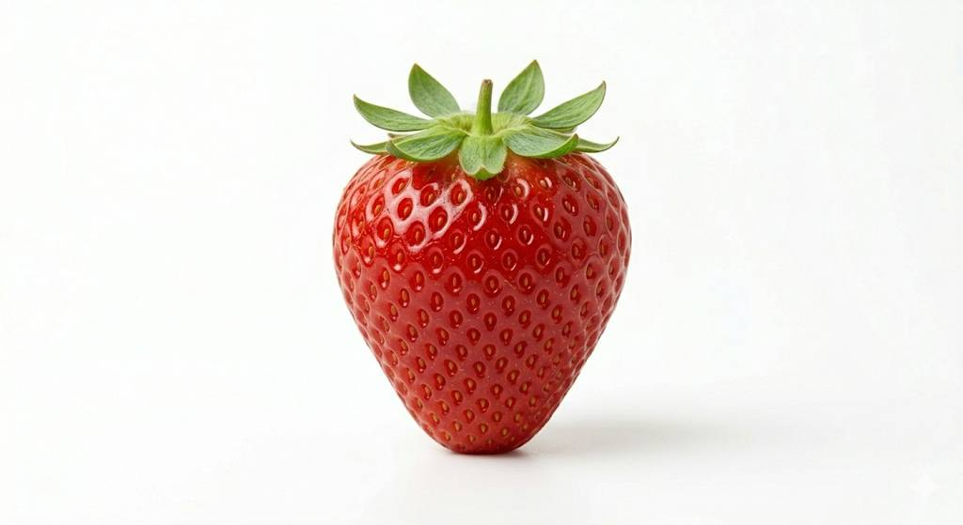
AI-generated image from Gemini
home/homeveg.jpg
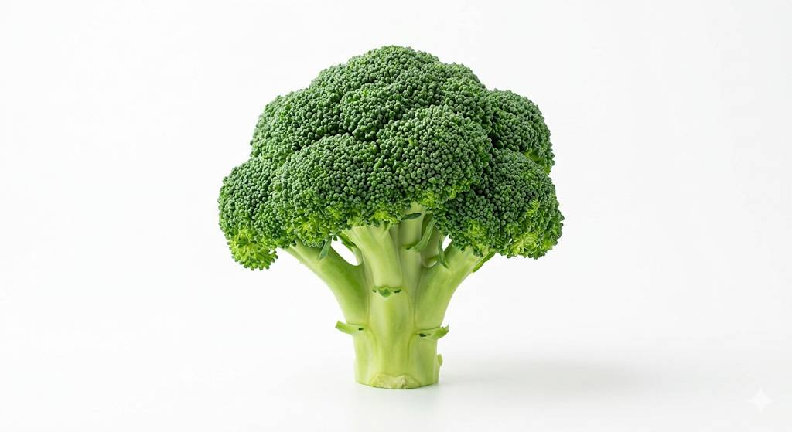
AI-generated image from Gemini
home/manwalking.jpg
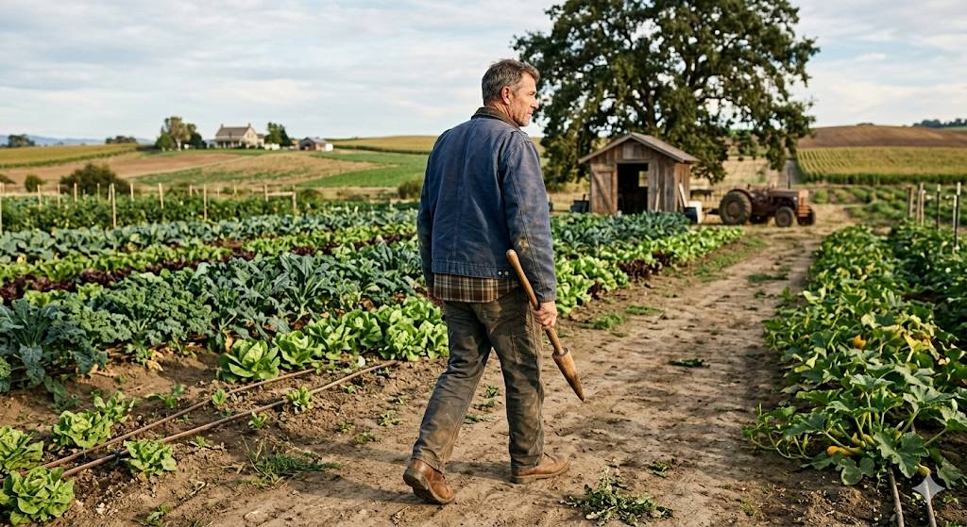
AI-generated image from Gemini
home/olderLady.jpg
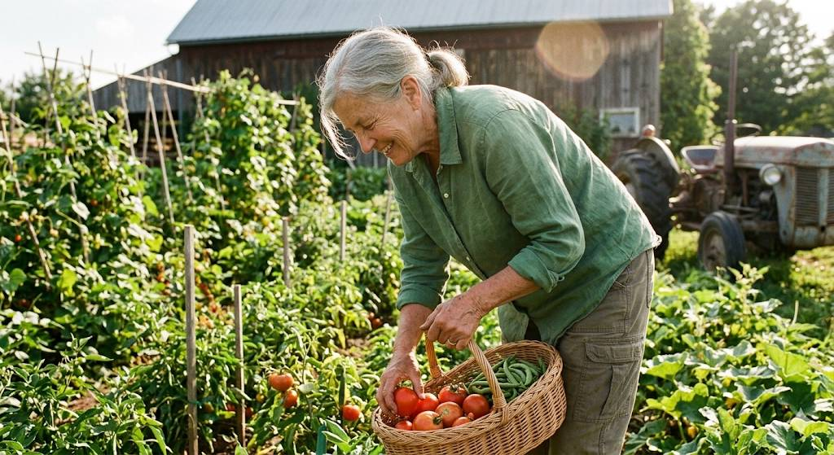
AI-generated image from Gemini
home/produceBox.jpg
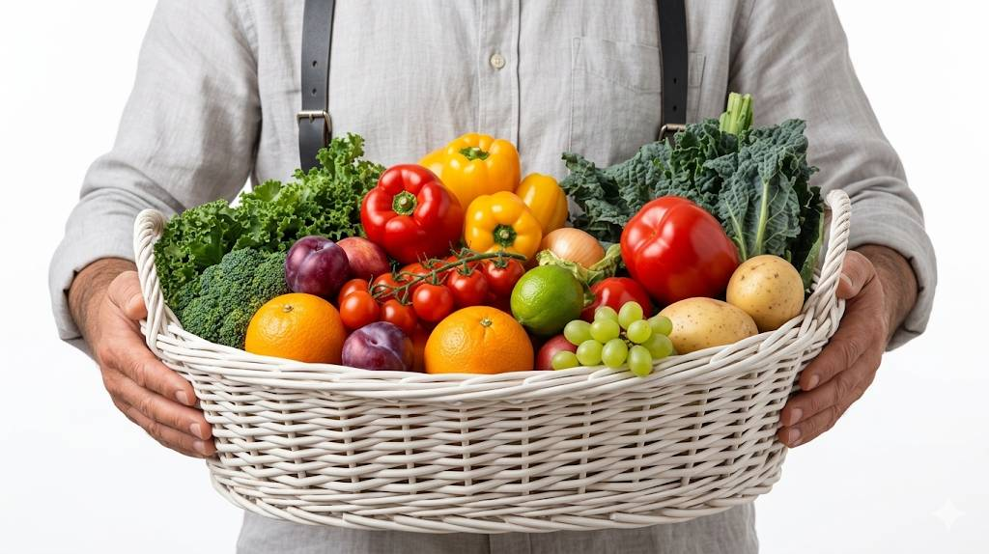
AI-generated image from Gemini
producers/greenValleyProduce.jpg
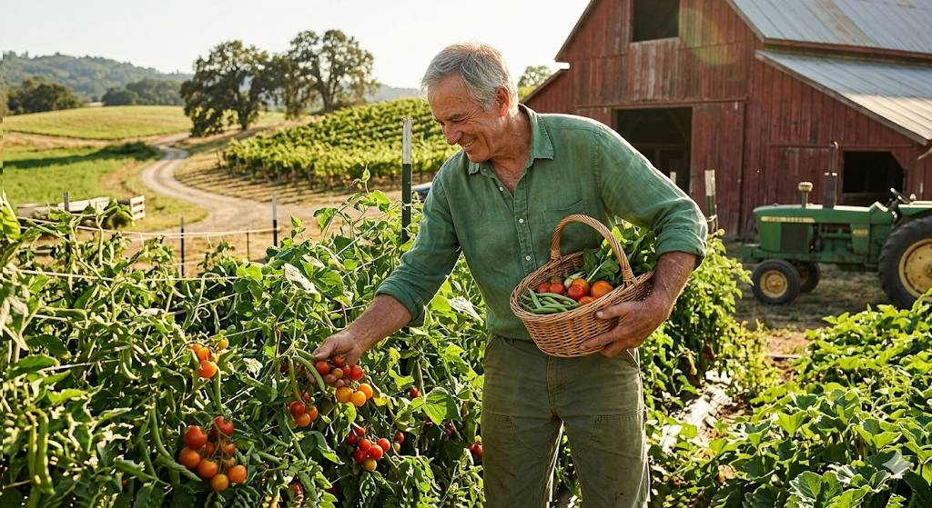
AI-generated image from Gemini
producers/meadowFreshOrganicFarm.jpg
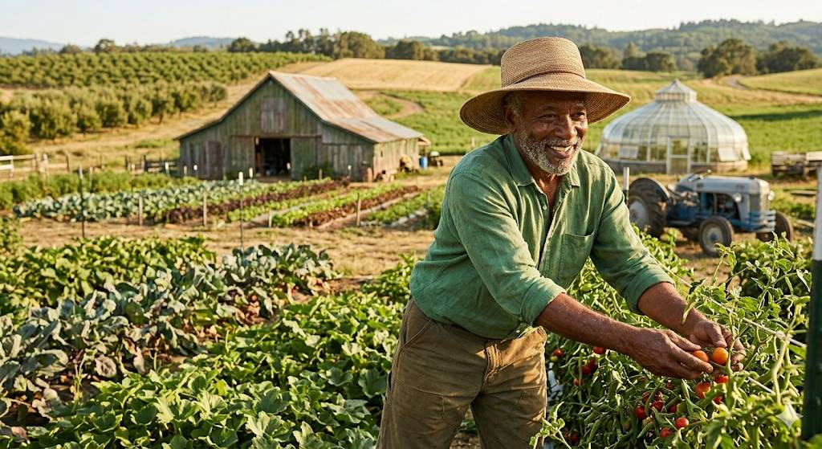
AI-generated image from Gemini
producers/oakridgeHarvestHub.jpg
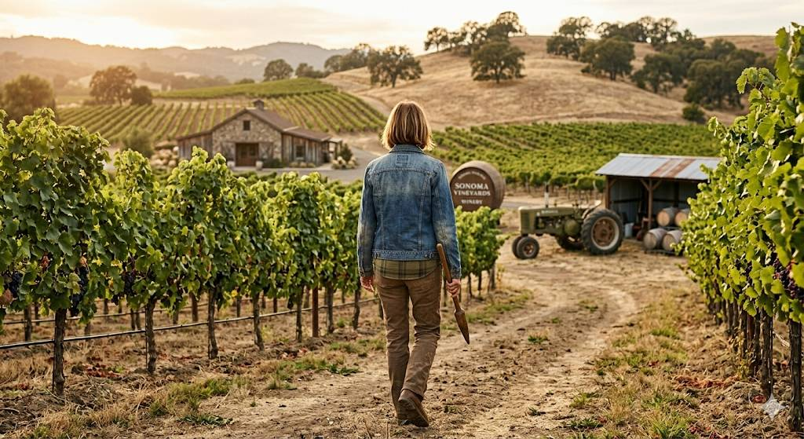
AI-generated image from Gemini
producers/sunnybrookFarm.jpg

AI-generated image from Gemini
producers/willowcreekFarm.jpg

AI-generated image from Gemini
products/apple.jpg
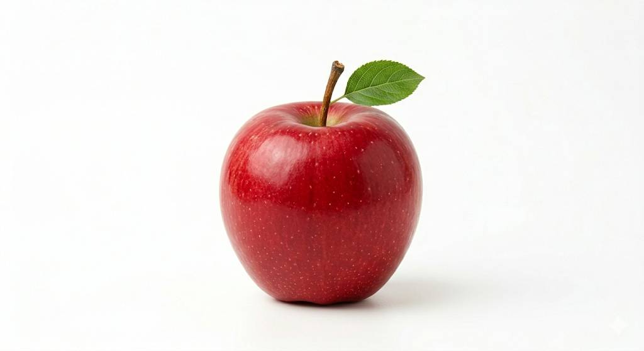
AI-generated image from Gemini
products/broccoli.jpg

AI-generated image from Gemini
products/carrot.jpg

AI-generated image from Gemini
products/cauliflower.jpg
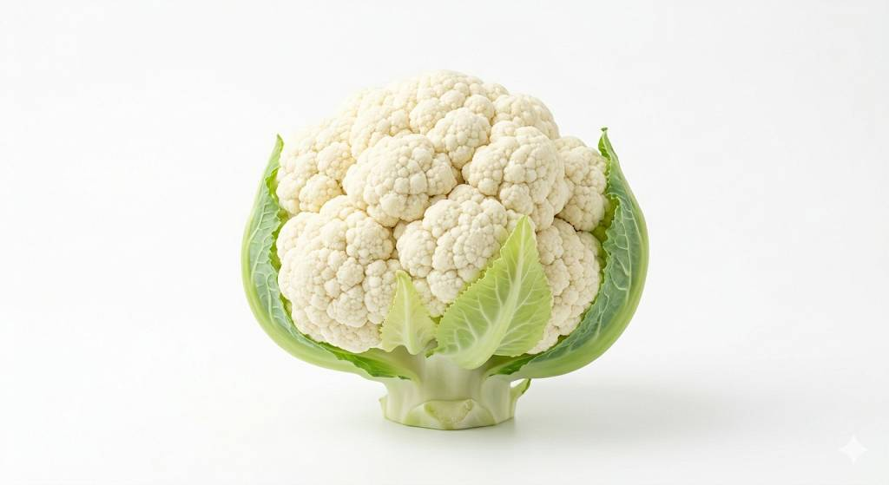
AI-generated image from Gemini
products/cheese.jpg
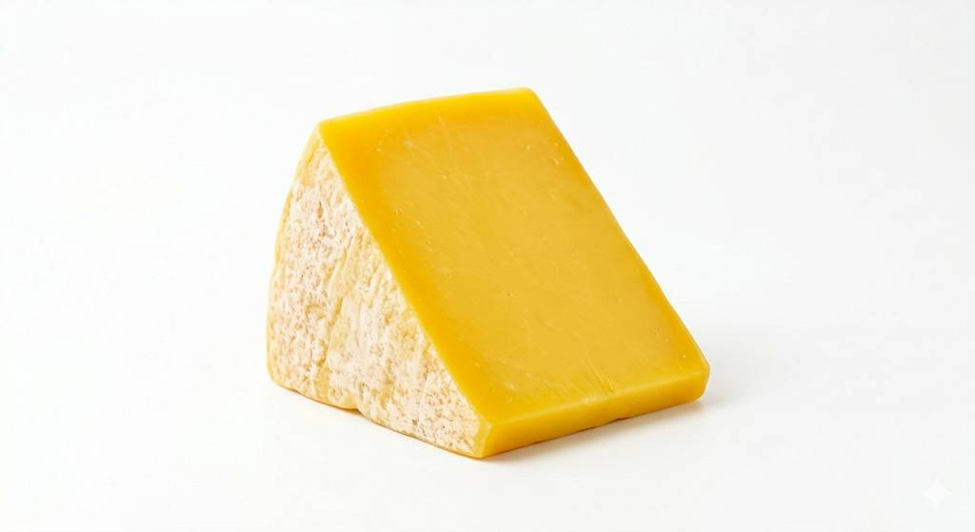
AI-generated image from Gemini
products/chickenbreast.jpg
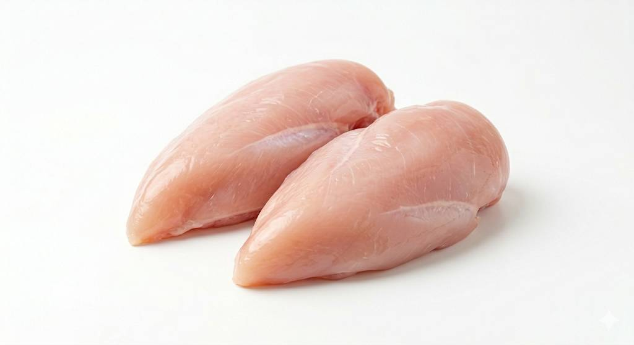
AI-generated image from Gemini
products/egg.jpg
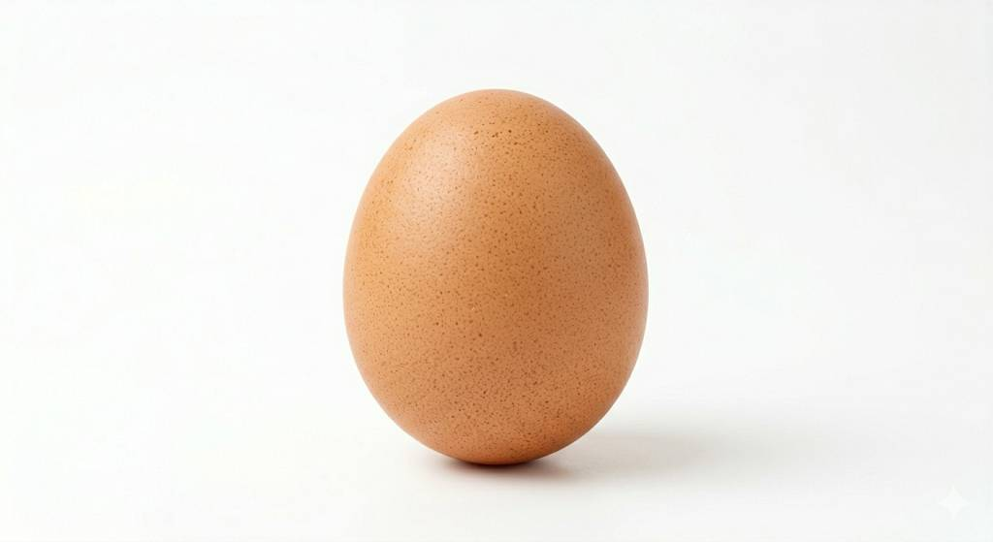
AI-generated image from Gemini
products/milk.jpg
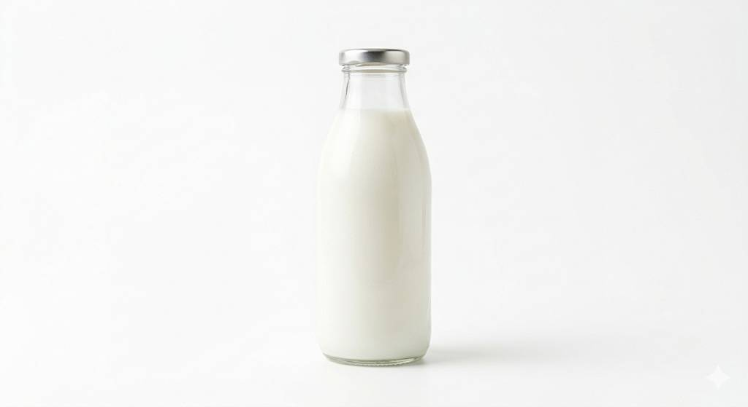
AI-generated image from Gemini
products/mincemeat.jpg
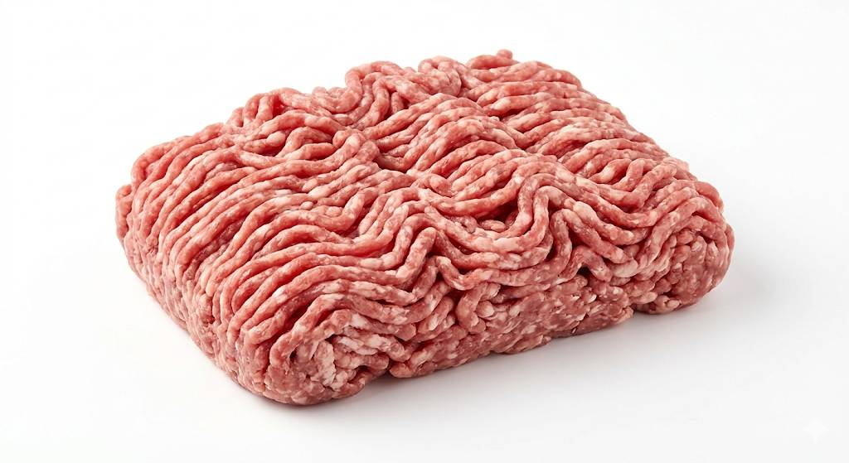
AI-generated image from Gemini
products/pear.jpg
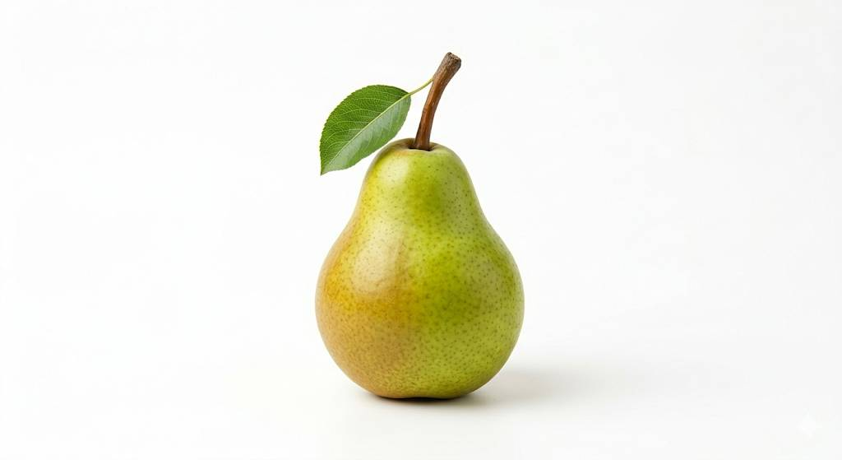
AI-generated image from Gemini
products/potatoes.jpg
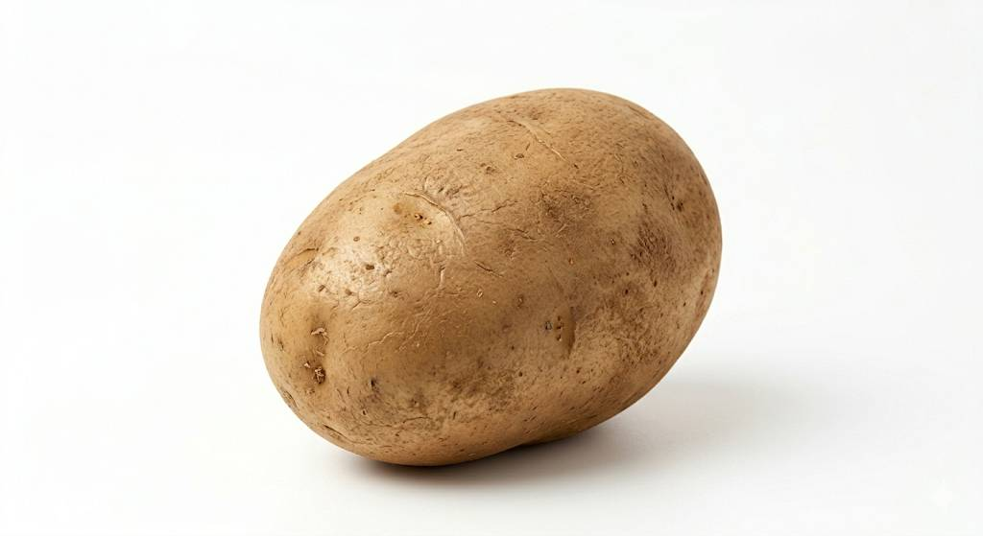
AI-generated image from Gemini
products/raspberry.jpg
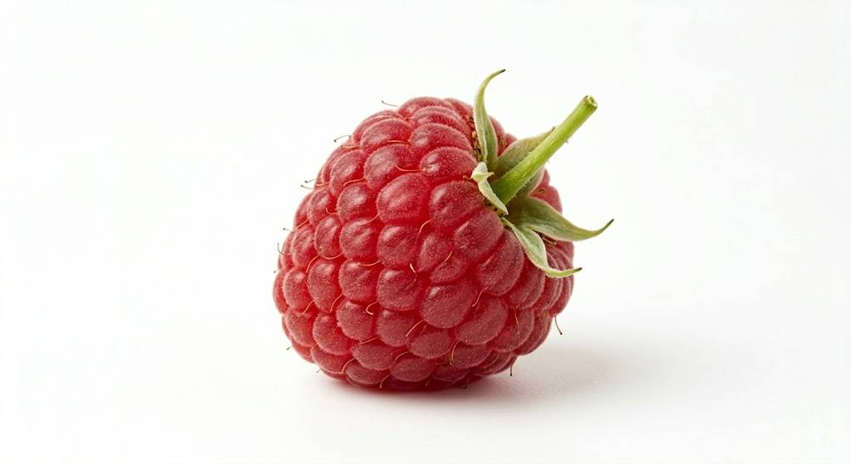
AI-generated image from Gemini
products/strawberry.jpg

AI-generated image from Gemini
products/yogurt.jpg
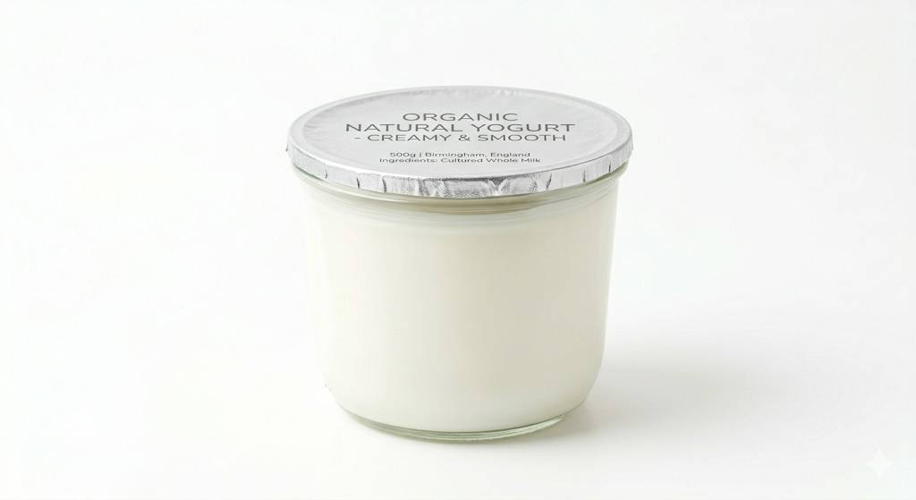
AI-generated image from Gemini

